**A REPORT IN VERTEBRATE FAUNA STUDY OF CENTRAL ZOO**



A REPORT IN VERTEBRATE FUNA STUDY OF CENTRAL ZOO

Submitted as a part of practical course of

+2 Science in Biology

Submitted to :

**SHREE SHANTI BHAGWATI SECONDARY SCHOOL**

**LETANG-4, MORANG**

**SUBMITTED BY : LAXMI ACHARYA**

**CLASS : 12**

**ROLL NO : 15**

**Date of submission :**

**LETTER OF APPROVAL**

This is to endorse that the report entitled "A REPORT FUNAL VERTEBRATES OF CENTRAL Z00" has been carried out by for the partial fulfillment of class 12 of science. They worked enthusiastically with sincere interest throughout this project. This report embodies their own work and has been done under my supervision. I hereby, approve this report for the presentation and submission in the examination.

Date : Magh, 2079

**Chakra Gautam**

Department of Science

i

**ACKNOWLWDGMENT**

This file report is our come kind guidance, direct guardianship and precious suggestion of our respected supervisor or this excursion associate proof.

We would like to express our gratitude toward all those staff of central zoo who were really cooperative in our study and activity responded to our queries and keenly participate in the interaction.

We are also very thankful to all teacher and non teaching staff of the Shree Shanti Bhagwati Secondary school and my parent for this wonderful support and made this event wonderful with vertebrate faunas. Who always remained based us and made us always felt comfortable to accomplish this task.

**ii**

**ABSTRACT**

This history of zoo animal welfare legislation extends back to 1876, and is often tied to general animals welfare regulations. As knowledge and societal values have changed, so have the focus of zoos and the regulations governing them. Today, the issue involved in zoo animal welfare are complex and broad - base. Building on the basic welfare tenets of adequate feed, water, Shelter, sanitation and veterinary care, current issues include the following: handling and training of coptivc animals, psychological well-being and environmental enrichment, enclosure design, species preservation, environmental and conservation issues, captive - breeding, programmes, complicating the matter. Further, government regulations try to assimilate all aspects of zoo animal welfare into the laws to provide human care and handling for all species concerned.

**iii**

**DECLARATION**

We hereby declare that the work present in this report has been done by our self. This report has been prepared after the central zoo visit on Magh, 2079 B.S. Zoo staff interactions queries and observation were done in the zoo and literatures were reviewed from the various sources for the secondary information to makes the report to partial fulfillment of class 12.

Laxmi Acharya

2079, Magh

iv

**CONTENTS**

1. LETTER OF APPROVAL…………………………………………………….…..….i
2. ACKNOWLEDGEMENT…………...……………………………………………….ii
3. ABSTRACT………………………………………………………………………...iii
4. DECLARATION……………………………………………………………….…….iv
5. LIST OF TABLES…………………………………………………………..….……..v

**CHAPTER 1 INTRODUCTION**

1.1 BACKGROUND……………………….……………………..………………………1

1.2 OBJECTIVE OF THE STUDY ……………………………………….......................1

1.3 LIMITATION……………………………………………….………………………1

**CHAPTER 2**

1. METHODOLOGY….....................................................................................................2

2. RESULT……………………………………...……………………………………...2

1. MAMMALS………………………………………............................2
2. REPTILE……………………………………………………………..2
3. FISH…………………………………………………………………...3
4. BIRD……………………………………………………......................3

**CHAPTER 3**

1. DISCUSSION AND CONCLUSION………………………………...........................4

2. REFERENCES…………………….…………………….…….…................................5

3. ANNEX………………………………………………………………………………...

v

**LIST OF TABLES**

LIST OF TABLES

Table no. 1 …………………………………………………………………………………… 2

Table no. 2 ……………………… ……………………………………………………………2

Table no. 3 ……………………… ……………………………………………………………3

Table no. 4 ……………………….……………………………………………………………3

Table no. 5 ……………………….……………………………………………………………3

vi

**INTRODUCTION**

**1.1 Background**

A place where animals live in captivity and are put on display for people to view known as zoo. Zoo also known as zoological garden or zoological park, institution devoted to the exhibition, preservation and study of animal. Although most people visit zoo for the entertainment. Zoo also educated the people about the animal behavior nature habitat and plight of animal in danger of extinction. Zoo plays a role in conservation of the threatened or endangered animal by developing innovation breeding program to maintain population of species that are in decline and also conduct scientific research on animal disease nutrition reproduction and behavior.

Today, most zoo gives animal welfare the highest priority, and where ever possible animals are housed in condition that mimics their natural habitat. While small animals cages with bars made it easy for zoo visitors to view the animal behavior, such a playing exposing and foraging for food. Zoo keeper found hat, in the absence of stimulating nature, environment caged animals developed abnormal behavior, often grooming themselves for hours or pacing restlessly in their narrow quarter, signs of mental deterioration.

Zoo are important for a number of reasons zoos offer a varieties of educational opportunities that teach about the behavior and natural history of zoos animals counterpart in the wild zoo scientists participate in the program that bring animals habitat in the wild and they conduct research that knowledge of animal biology.

The central zoo of Nepal, it was established in 1932 B.S by late prime minister Juddha Bhadur Rana as a private zoo. After the politics change in 1951, the ownership of central zoo came under his majesty Government of Nepal and opened to the public in 1956 B.S over the year the management of zoo was under various government department ultimately on 29th  December 1995 on occasion of golden jubilee of his majesty late king Birendra Bir Bikram shah Dev's auspicious birth day the management of central zoo was formally handed over to the king Mahendra trust for nature conservation for 30 years.

The central zoo has yearly on million visitors. In a special festival (Bothe Jatra) about 34 thousand people visit the central zoo on a single day. The central zoo has also Management and animal sponsorship programs under zoo animal welfare scheme. The zoo has already started an animal's sponsorship cost varies from 170 US $ to 3,340 US $. This program is mainly to support animal feeding whose cost is about 40 lakhs Nepalese rupees yearly at present.

**1.2 OBJECTIVE OF THE STUDY**

The main objective of the study were :

1. To list out different types of animals kept in the zoo.
2. To evaluate the living condition of animals present in the zoo.

**1.3 LIMITATION**

1. Duration of the study is very short.
2. Danger animals were not study in nearly.

3. Microscopically not observed for health condition.

1

**METHODOLOGY**

**2.1 Study Area**

The Central zoo is located in Jawalakhel of lalitpur district. It covers a area of six hectare. The zoo contains 68 sections: 7 for reptiles, 7 for fishes, 28 mammals and 28 of birds. It houses over 861 animals of 108 species. Among these 30 are mammals 53 birds: and 10 reptiles and 15 fish species. The central zoo exhibits 13 out of 38 endangered animals' species of Nepal. The central zoo have initiated an animal exchange program with some zoo aboard and have brought some exotic wild life species such as a Seaming Ostrich, Hippo and some other birds species and displayed successfully. Recently, 5 Red Eared Slider Turtles Trachenys script elegans have been collected and placed for exhibit at reptile house in section No.3. Similarly, 5 new species of fishes have been added in the aquariumat section3.

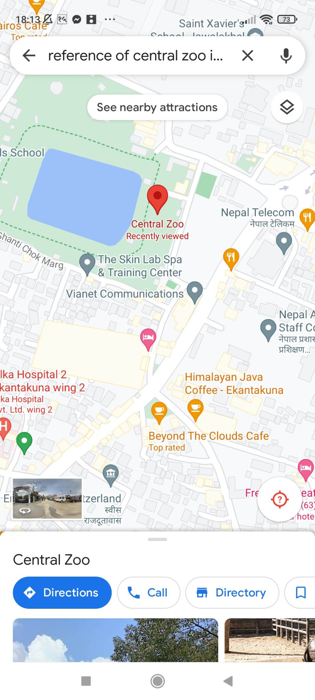

Figure 1: Geological map showing study area (Central zoo)

**2.2 Method**

The zoo was visited on falgun 2078. The animal were directly observed necessary information such as their counted and living conditions as their habitat and health studied. In addition, More information was collected by interviewing zoo keepers and authorities of zoo. The date was also collected from secondary source as book, check list of animals etc. of zoo and websites.

2

**RESULT**

Table no. 1 Mammals

|  |  |  |  |  |  |  |
| --- | --- | --- | --- | --- | --- | --- |
| S.N | Common Name | Scientific Name | Origin | Total | Male | Female |
| 1 | Asian Elephant | *Elephus maximus* | Native | 1 |  | 1 |
| 2 | Rabbit | *Oryctolagus* | Native | 22 |  | 22 |
| 3 | One Horned Rhinoceros | *Rhinocerous* *unicornis* | Native | 2 | 1 | 1 |
| 4 | Jungle Cat | *Felisaureus* | Native | 3 | 2 | 1 |
| 5 | Royal Bengal Tiger | *Penther* *tigers* | Native | 3 | 2 | 1 |

Table no. 2 Reptiles

|  |  |  |  |  |  |  |  |
| --- | --- | --- | --- | --- | --- | --- | --- |
| S.N | Common Name | Scientific Name | Origin | Total | Male | Female | Infat/ Unknown |
| 1 | Aldabra Gaint Tortise | *Geochelone gigantean* | Native | 2 | 2 |  |  |
| 2 | Gharial Crocodile | *Gavialis* *gangeticus* | Native | 2 |  | 1 |  |
| 3 | Common monitor lizard | *Varanus* *bengalensis* | Native | 1 | 1 |  |  |
| 4 | Cobra | *Naja* *naja* | Native | 2 |  |  | 2 |
| 5 | Indian foofed Turtle | *Kavchuga* *tecta* | Native | 1 |  |  | 1 |

Table no.3

FISHES

|  |  |  |  |  |  |  |  |
| --- | --- | --- | --- | --- | --- | --- | --- |
| S.N | Common Name | Scientific Name | Origin | Total | Male | Female | Infat/ Unknown |
| 1 | Angel fish |  | Exotic | 3 |  |  | 3 |
| 2 | Piranha |  | Exotic | 3 |  |  | 3 |
| 3 | Sabun king | *Earassius spp* | Exotic | 10 |  |  | 10 |
| 4 | Black tiger shark | *Pangasivs sutehi* | Exotic | 49 |  |  | 49 |
| 5 | Red oranda | *Carassius spp* | Exotic | 13 |  |  | 13 |

3

Table no. 4

Birds

|  |  |  |  |  |  |  |  |
| --- | --- | --- | --- | --- | --- | --- | --- |
| S.N | Common Name | Scientific Name | Origin | Total | Male | Female | Infat/ Unknown |
| 1 | Bran Owl | *Tyto alba* | Native | 2 |  |  | 2 |
| 2 | Common crane | *Grus grus* | Native | 1 |  |  | 1 |
| 3 | Gryleg Goose | *Arser anser* | Native | 64 |  |  | 64 |
| 4 | Fantail pigeon | *Columbidae* | Native | 2 | 1 | 1 |  |
| 5 | White dove | *Colombus spp* | Native | 1 |  |  | 1 |

Table no. 5

|  |  |  |
| --- | --- | --- |
| Categories | Species | Number |
| Mammals | 5 | 5 |
| Reptiles | 5 | 5 |
| Fishes | 5 | 5 |
| Birds | 5 | 5 |
| Total | 20 | 5 |

4

**DISCUSSION AND CONCLUSION**

All together 1035 animals belonging to 20 species are kept for exhibit in the central zoo of Jawalakhel, 223 animal of 5 belong to class mammalian, 21 animals of 5 species belong to class Reptilian, 385 animals of 5 species belong to class Pisces and 259 animals of 5 species belong to class aves. Regarding the living condition of animal in zoo, it has been found to be improved since zoo was handed over to the king Mahendra trust for Nature conservation. Despite some of the condition are better than before as health care of animals, proper diet, clean environment. It can't be ignored that it is not built or managed according to international criteria and guidance. Today, most zoos give animals welfare the highest priority and wherever possible, animal are housed in condition that mimics the natural condition.

5

**Refrences**

1. KTMC central zoo (2004). A brochure published by King Mahendra Trust for nature conservation / central zoo, P.O. Box 12466, Jawalakhel, Lalitpur, Nepal.
2. KMTNC / central zoo (2005). King Mahendra Trust for nature conservation / central zoo checklist of animals, March 2006 (Falgun 2061). King Mahendra Trust for nature conservation / central zoo P.O Box 12466, Jawalakhel, lalitpur, Nepal.
3. Microsoft Corporation (2003). Mircrosoft Encarata Reference Library 2004. Zoo.
4. www.google.com

6